Monitoring app

Monitoring is a mobile application that allows you to view all the legislations and rights that provides protection from privacy breaches against Australian government agencies and outside hackers. This application also preventing other mobile applications to accessing the microphone and it also guide you to make complaint for different types of breaches.

**Which devices does the mobile app support?**

You can install Monitoring app on any mobile devices that supports Android (mobile phones and tablets) operating systems.

**Instructions to use**

1. To use the app, you need to sign in using the Name and number of your monitoring App Account.

If you do not have a monitoring App account yet, click register and Create new account by filling your details.

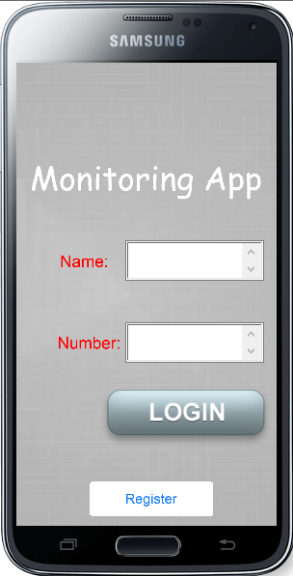

1. **App Overview**
   1. Monitoring app consist of three options on the homepage.

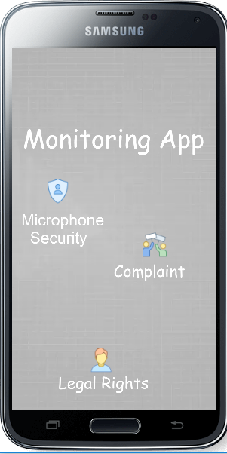

* 1. Microphone Security option will be for you to manually enable or disable the microphone access.

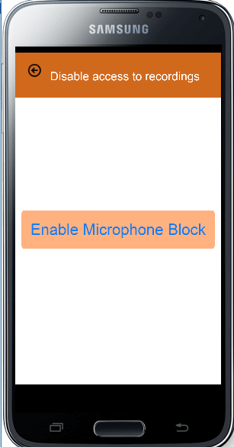

* 1. Legal rights option click will direct you to the information about the Acts and rights you have for your protection. It will allow you to read the information about the Acts in the app or online on the official website for every Act.

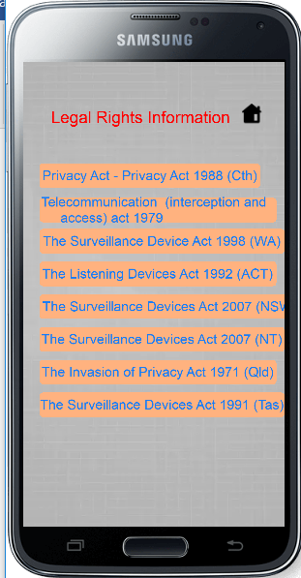

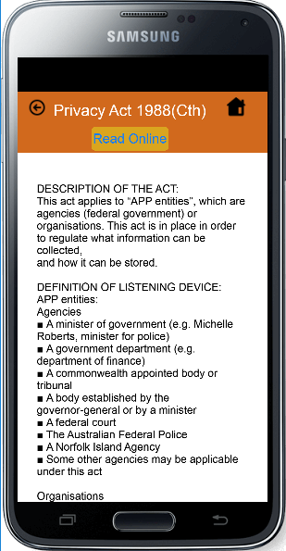

* 1. Complaint function will allow you to complaint for Breaches from government agencies and breaches from unknown sources. It will direct you to the website where you can complaint.

